**BIT PASKAITOS:**

Planas:

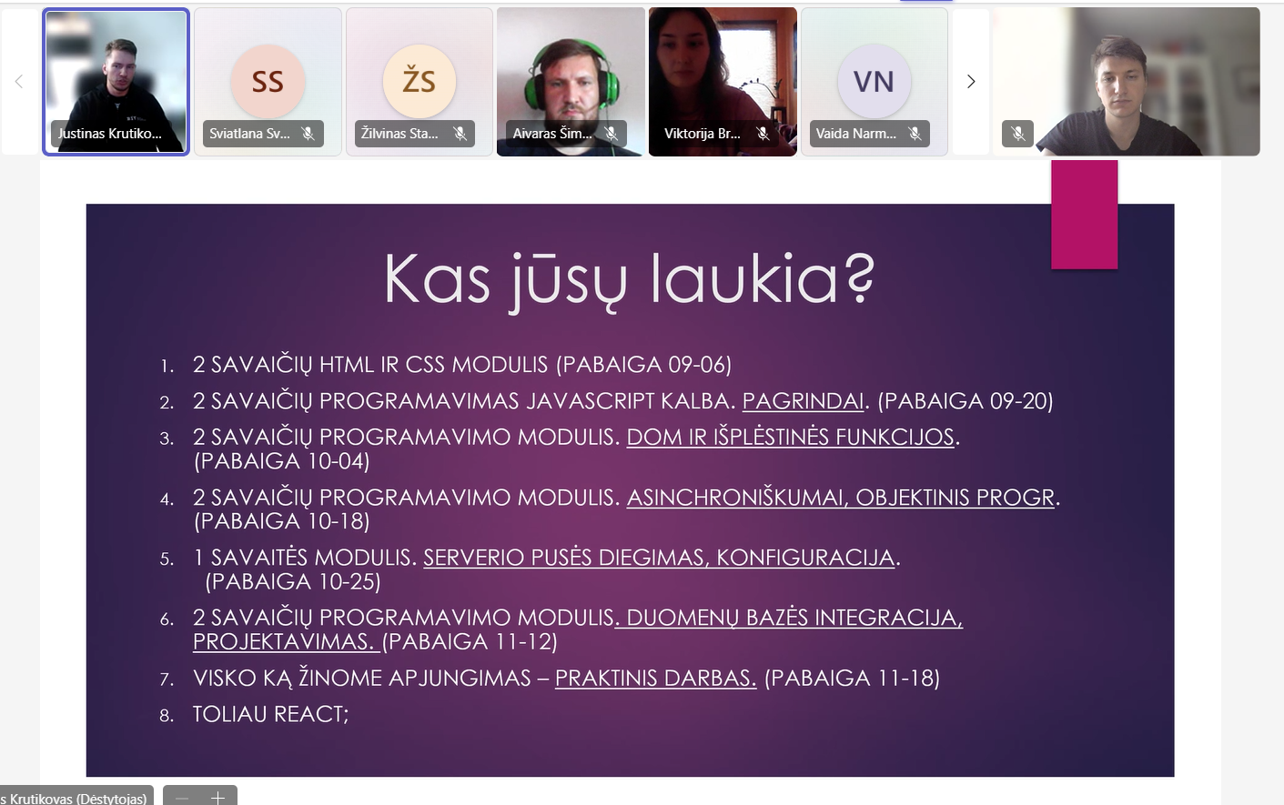

**Discord:**

[**Midnight IT (disco arnasmaliukevicius@balticinstitute.onmicrosoft.comrd.com)**](https://discord.com/invite/RFJDCkYmEa)

**Drive:**

[**PROG NF ONLINE 24 08 26 – „„Google“ diskas“**](https://drive.google.com/drive/folders/1ielgTZPfw_PlKVnCf8R0G1NRhfWqZRgn)

**Mokymas medžiaga:**

[**W3Schools Online Web Tutorials**](https://www.w3schools.com/)

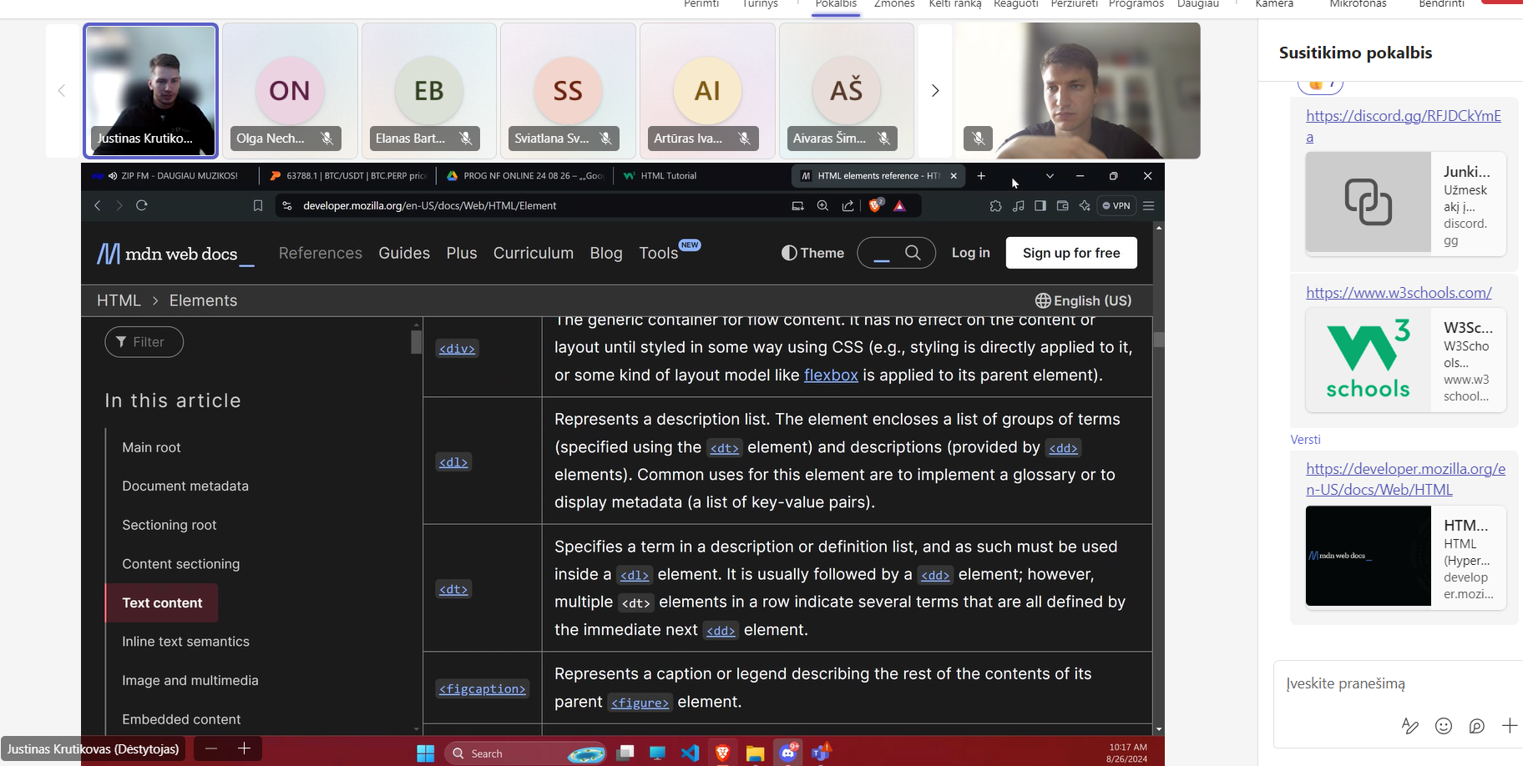

[**HTML: HyperText Markup Language | MDN (mozilla.org)**](https://developer.mozilla.org/en-US/docs/Web/HTML)

**Mokėt extentionus**

[**https://medium.com/@NeotericEU/single-page-application-vs-multiple-page-application-2591588efe58**](https://medium.com/@NeotericEU/single-page-application-vs-multiple-page-application-2591588efe58)

**multi page**

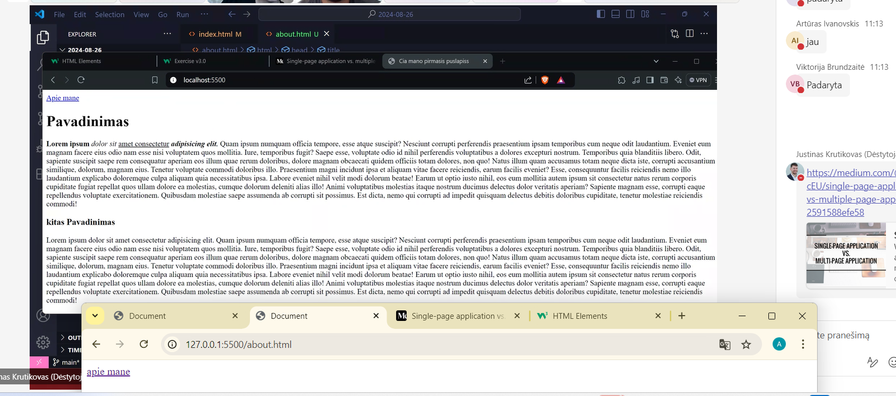

**Ip skirtumai**

**Per rageli pasiziuret page**

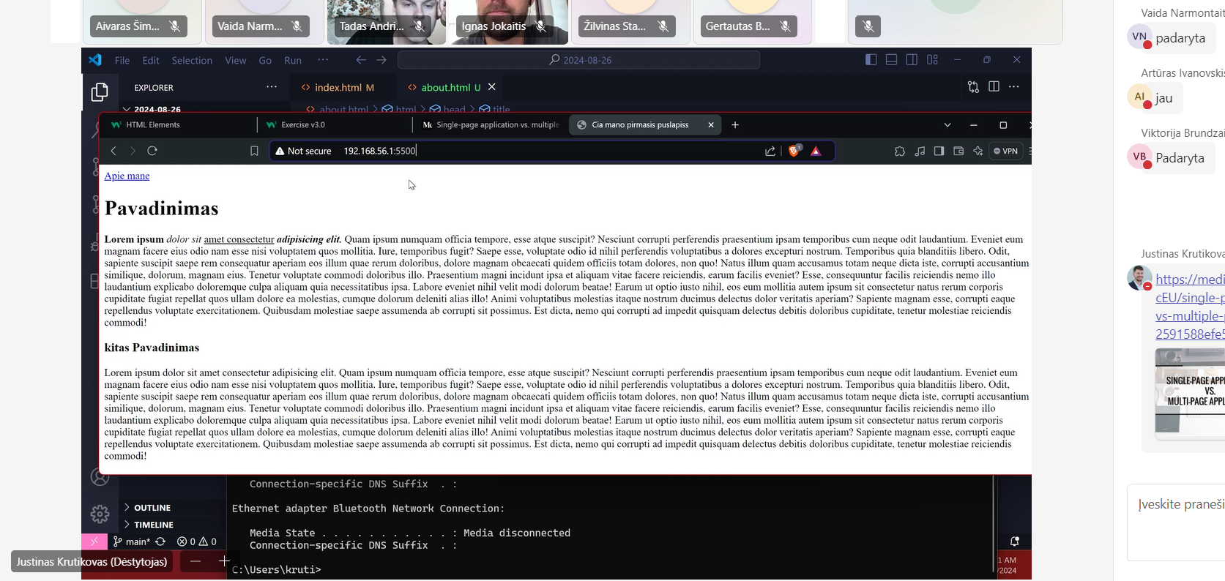

**Cmd naudojant ip nustatant**

[**https://github.com/justyzas/24-08-26-PROG-NF**](https://github.com/justyzas/24-08-26-PROG-NF)

**drive uzduotis**